Awais Afridi 876741

Q1: Define the relationship between Marginal Rate of Substitution (MRSx,y)  and marginal utility.

In economics, the marginal rate of substitution (MRS) is the amount of a good (x) that a consumer is willing to give up for another good (y), as long as the new good (y) is equally satisfying.

While the amount of willing to use a particular good (x) or (y) is determine by its Marginal Utility function.

The relationship between the two terms MRSxy and MU is such that Marginal Rate of Substitution of goods x,y is the ratio between Marginal Utility of each good and it gives us information about marginal substitution preference of particular goods for a particular consumer.

Q2: Consider a poor student who covers most of his dietary needs by eating cheap breakfast cereal, since it contains most of the important vitamins. As the price of cereal increases, he decides to buy even less of other foods and even more breakfast cereal to maintain his intake of important nutrients. This makes breakfast cereal a Giffen good for the student.

Describe in words the substitution effect and the income effect from this increase in the price of cereal. In which direction does each effect move, and why? What does this imply for the slope of the student's [demand curve](https://moodle.unive.it/mod/resource/view.php?id=38952) for cereals? NOTE: This question is optional.

The substitution effect (SE) and the income effect (IE) are effects concerning changes in price of a good or service on consumption of that good/service in question, on the demand curve.

The SE shows us the change in quantity consumed by a consumer of a certain good (which has become costly and is substituted with another good that is cheaper).

The second one (IE) regards the purchasing power of the consumer.

As price rises, the consumer becomes relatively shorthanded in purchasing because his income does not meet his requirements as earlier times. Usually the most impact is held by the substitution effect and consumer keep on substitution of products from x to y, the total effect usually reinforces the substitution effect, both IE and SE being negative, , giving a downwards slope to the demand curve.

When dealing with inferior good, the two effect move in different directions, the substitution effect being still negative (less quantity consumed) and the income one being positive (more quantity consumed, because when income lowers obviously the consumption of inferior goods increases). However most of the times the substitution effect is stronger, so the total effect is still negative.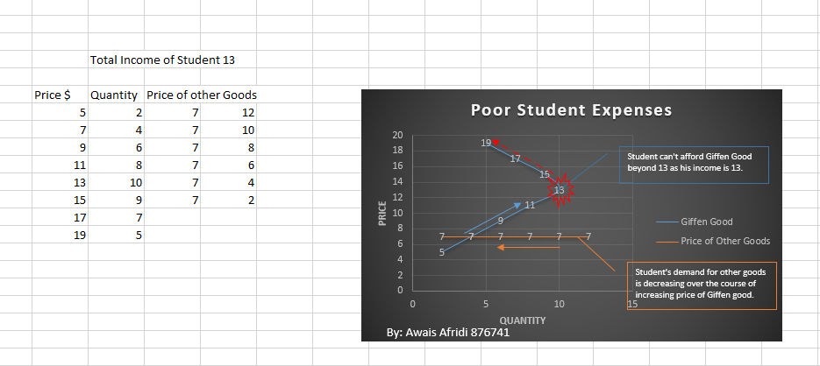

Q3: A consumer loves to spend all her income in tramezzini (good x) and prosecco (good y).

Her preferences are described by the following utility function:

U(x,y) =xy2

In Venice, the price of tramezzini is Px=1 and the price of prosecco is Py=3.

The consumer's income is 18 euro.

a) Write the budget constraint and represent it in a diagram (indicating clearly the intercepts).

b) Calculate the [optimal consumption](https://moodle.unive.it/mod/resource/view.php?id=39929) bundle for this consumer (MUx=y2 ; MUx=2xy)

c) Now assume that the price of tramezzini doubles, i.e. Px'=2. Define the new budget constraint and the new consumption bundle.

d) Now assume that the income doubles, i.e. I'=36 euro. Define the new budget constraint and the new consumption bundle.